EJC EXAMPLE 5
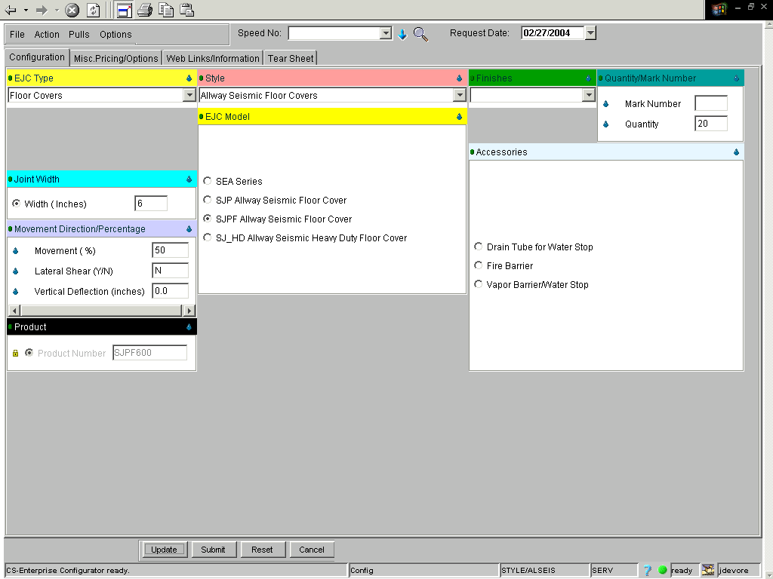

Click File, Save Current and Create New.
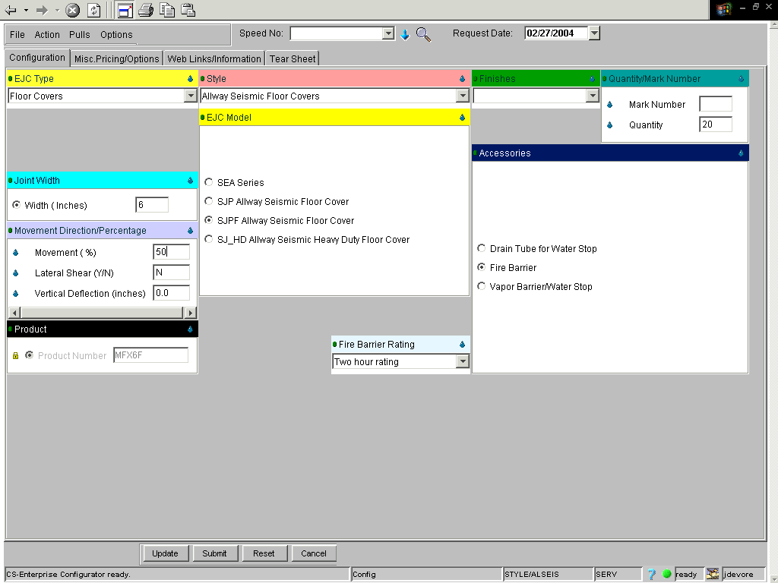
If done correctly, your price will equal $1,663.32.

